Урок 8 elementary
Подготовим наши органы речи к воспроизведению английских звуков.
Разминка 8..mp3
O
[ɒ] – hot, top, rock, not, shot, box. A fox in a box. A fox on the rocks. A boxing fox.
[ɜʊ] – no, go, tone, node, nope, lope, code, so, mode, home, tote. My phone phones only in the morning.
[Λ] – another, other, cover, mother, brother, son, mom.
[au] – ou/ow - town, down, noun, count, found.
[ɔ:] – port, fork, lord, dormitory, sort, horn, morning. Oliver Oglethorpe ogled an owl and oyster. Did Oliver Oglethorpe ogle an owl and oyster? If Oliver Oglethorpe ogled an owl and oyster, Where’s the owl and oyster Oliver Oglethorpe ogled?
[ɔi] – Oi/oy What noise annoys an oyster most? A noisy noise annoys an oyster most. Toy boat, toy boat, toy boat.
На предыдущих занятиях мы работали со следующими вещами:
- Мы научились выражать типичное действие при помощи различных глаголов, включая глагол to be и have got, а также действие в процессе. Для простого действия мы будем использовать базовую форму глагола для всех лиц и чисел, кроме тех случаев, когда подлежащим является ОН, ОНА, ОНО (и все, что на них можно заменить). Для вопросов и отрицаний будет использоваться «хелпер» do/does. Глагол to be и have got не требуют «хелпера» и меняются по лицам и числам в настоящем времени.

- Действие в процессе выражается при помощи формулы be+Ving, где be меняется по лицам и числам, а для вопросов и отрицаний используется be как обычно.

- Кроме этого, мы научились описывать места при помощи структуры there is/are, которая отличается от русского языка по порядку слов и построению предложений.

- Мы уже можем описать характер и внешность, одежду и стиль, ежедневные действия, перемещаться по городу и купить что-либо в магазине. Теперь пора выводить эти знания в более активную фазу.
Прослушайте диалоги на внешнем ресурсе и выполните тесты к ним:
- Трек и скрипт http://esl-lab.com/rent/rentsc1.htm
Тест http://esl-lab.com/rent/rentrd1.htm
- Трек и скрипт http://esl-lab.com/supermarket/supermarketsc1.htm
Тест http://esl-lab.com/supermarket/supermarketrd1.htm
- Трек и скрипт http://esl-lab.com/flea/fleasc1.htm
Тест http://esl-lab.com/flea/fleard1.htm
Посмотрите видео на внешнем ресурсе:
- http://www.youtube.com/watch?v=cOKde_7ZLUM
- http://www.youtube.com/watch?v=Q-1tfWzHgOA
- http://www.youtube.com/watch?v=EEmELw8djRA&list=PLwh2W4PrDw1ksvzS0jmnYiimqYRN-8Y-_
Вставьте в диалог недостающие фразы.
Диалог

- Hello! Can I help you? - *************************
- Ok. Anyway I am over here. If you need help, just call me.
- Thanks!

(5 minutes later)
- I would like to try this suit on. I need size 7.
- *************************
- Thank you.
- ************************* is over there. Go straight ahead and turn left at the jeans stand.
- Thank you.(5 minutes later). I like this suit, but it’s a bit too loose. Do you have a smaller size?
- Here you are – size 6.
- But it is a different color. I don’t want a blue suit, blue color doesn’t become to me. I want a red one.
- I’m sorry, but *************************. Would you like a green suit?
- Ok. Is this suit size 6?
- it is size 5. Would you like to try it on?
- No, size 5 is too small for me.
- Sure. *************************
(5 minutes later)
- It fits me perfectly. *************************
- It is $75.
- Oh, that is expensive. I am a regular client. *************************
- Oh, do you have a discount card?
- Sure I do.
- Ok, let’s see. Yes, your discount is $10. Is it Ok with you?
- That’s wonderful. Put it in the bag.
- Do you pay cash or by a credit card?
- *************************. Do I owe you $65?
- Exactly. Here you are. Thank you for purchase. Good bye!
- Bye!
Проверь себя

- Hello! Can I help you?
- No, thank you, I just want to look around/I am just looking.
- Ok. Anyway I am over here. If you need help, just call me.
- Thanks! (5 minutes later)
- I would like to try this suit on. I need size 7.
- Here you are – size 7.
- Thank you.
- The fitting room/the changing room is over there. Go straight ahead and turn left at the jeans stand.
- Thank you. (5 minutes later)
- I like this suit, but it’s a bit too loose. Do you have a smaller size?
- Here you are – size 6.
- But it is a different color. I don’t want a blue suit, blue color doesn’t become to me. I want a red one.
- I’m sorry, but we don’t have these suits your size in red. Would you like a green suit?
- Ok. Is this suit size 6?
- it is size 5. Would you like to try it on?
- No, size 5 is too small for me.
- Sure. Here you are – size 6. (5 minutes later)
- It fits me perfectly. How much is it?
- It is $75.
- Oh, that is expensive. I am a regular client. Can I have a discount?
- Oh, do you have a discount card?
- Sure I do.
- Ok, let’s see. Yes, your discount is $10. Is it Ok with you?
- That’s wonderful. Put it in the bag.
- Do you pay cash or by a credit card?
- Cash. Do I owe you $65?
- Exactly. Here you are. Thank you for purchase. Good bye!
- Bye!
Выполните паттерны на фразы в магазине.
Паттерны на фразы в магазине
patterny_frazy_v_magazine_plyus_idiomy-1.pdf
Покупать мы можем не только одежду. Зачастую нужно купить продукты. Не всегда рядом есть супермаркет, и тогда приходится идти в местный магазинчик и делать покупки там. А для этого нужно знать названия продуктов.
Лексика «Продукты» produkty_v_magazine2.pdf
Чтобы купить что-то в упаковке, вам нужно назвать количество упаковок. А как называются различные контейнеры?
Containers
пакет, мешок | bag | [bæg]
бочонок | barrel | [bærəl]
коробка | box | [bɒks]
ящик | crate | [kreit]
алюминиевая банка | can | [kæn]
пакет, картонная упаковка | carton | [ka:tn]
стеклянная банка | jar | [dƷa:]
пакет, пачка | packet | [pækit]
горошочек | pot | [pɒt]
жестяная банка | tin | [tin]
контейнер-корытце | tub | [tᴧb]
тюбик | tube | [tju:b]
пакет, упаковка (для кетчупа, майонеза) | sachet | [sə∫e]

Containers 2
Word | Definition | Translation | Examples
a bag | a container made of paper, cloth, or thin plastic which usually opens at the top | пакет, мешок | a paper bag, a plastic bag, a garbage bag
a barrel | a large curved container with a flat top and bottom, made of wood or metal, and used for storing beer, wine etc | бочка, бочонок | an oak barrel, barrels of beer
a box | a container for putting things in, especially one with four stiff straight sides | коробка, короб, коробок, шкатулка, ящик | a cardboar/wooden/plastic box, a toolbox, a shoebox, a matchbox
a can | a metal container in which food or drink is preserved without air | (жестяная) банка, (жестяная) коробка | a Coke can, a couple of cans of soup
a carton | a small box made of cardboard or plastic that contains food or a drink | коробка, упаковка | a carton of fruit juice, a milk carton, an egg carton
 | Am. a large container with smaller containers of goods inside it | блок | a carton of cigarettes
a drum | a large round container for storing liquids such as oil, chemicals etc | бочка | an oil drum
a jar | a glass container with a wide top and a lid, used for storing food such as jam or honey | банка | a jam jar, a jar of peanut butter
a packet (Am. a pack) | a container made of paper, plastic, or cardboard that something is sold in | пакет, пачка | a packet of envelopes, a packet of cigarettes, a cereal packet
a pot | a container for a plant, usually made of plastic or baked clay | (цветочный) горшок | herbs growing in pots
 | Br. a round container for storing foods such as jam that are slightly liquid, or for substances such as glue or paint | горшочек | a pot of blue paint, a jam/paint/yoghurt pot
a sachet (Am. a packet) | a small plastic or paper package containing a liquid or powder | пакетик-саше (пробник), упаковка | a sachet of shampoo
a tin (Am. a can) | a small metal container in which food or drink is sold | консервная банка | a tin of baked beans
 | a metal container with a lid in which food can be stored | (жестяная) банка | a biscuit tin
a tub | a small container made of paper or plastic with a lid, in which food is bought or stored | контейнер (в виде корытца, ванночки) | a tub of ice cream, a margarine tub
 | an open container that is usually round, used for washing, storing things in etc | кадка | trees growing in tubs
a tube | a narrow container made of plastic or soft metal and closed at one end, that you press between your fingers in order to push out the soft substance that is inside | тюбик | a tube of toothpaste

А теперь для полноты картины нам просто необходимо взглянуть, как это всё выглядит.
Картинки на тему Containers
- a bag of crisps: | 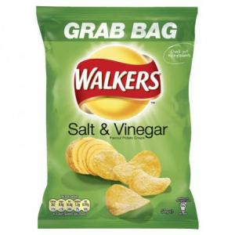
- a beer barrel: | 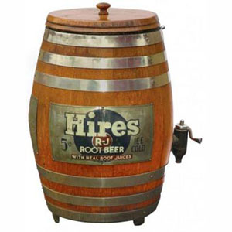
- a box of matches: | 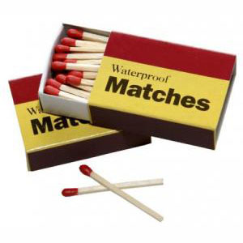
- a can of cola: | 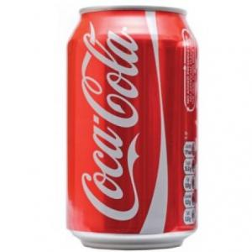
- a carton of eggs: | 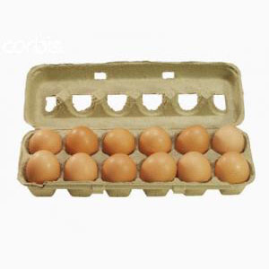
- a carton of milk: | 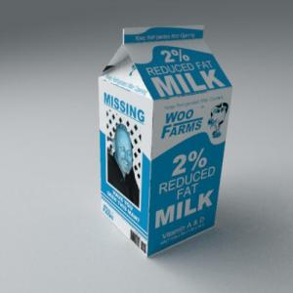
- a jar of pickles: | 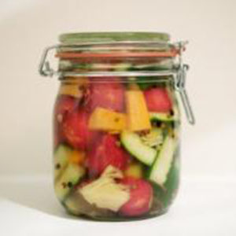
- a packet of cheese: | 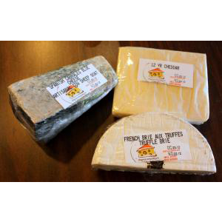
- a pot of honey: | 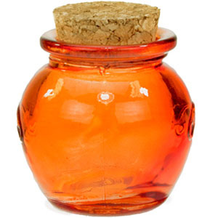
- a sachet of tomato sauce: | 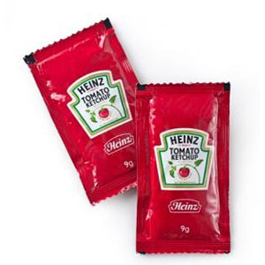
- a tin of beans: | 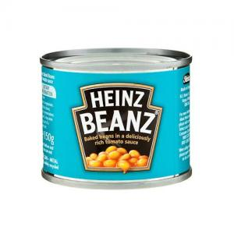
- a tin of tuna: | 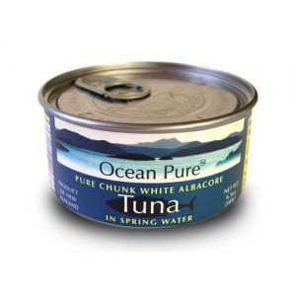
- a tub of margarine: | 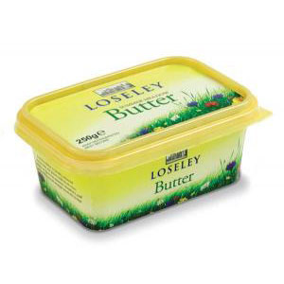
- a tube of toothpaste: | 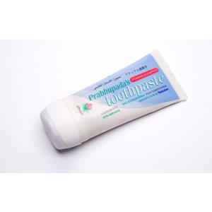

Еще есть особые названия у крышек этих контейнеров. В русском языке слово “крышка” обозначает очень широкое понятие и называет всё, что закрывает что-либо. Оно соответствует целому ряду слов в английском языке. Но как их различать? Попробуем разобраться, проведя маленькое расследование.
Слово | Определение | Пример
a lid | a cover over a container that can be removed or opened by turning it or lifting it | a dustbin lid, I can’t get the lid off this jar
a cap | a protective cover or top for a pen, bottle, etc | a lens cap
a top | a thing that you put on the end of sth to close it | a bottle with a screw top, Where’s the top of this pen?
a cover | a thing that is put over or on another thing, usually to protect it or to decorate it | a cushion cover, a plastic waterproof cover for the stroller
Очевидно, в данном случае словарные дефиниции не дают исчерпывающего ответа на вопрос о различиях в употреблении между этими четырьмя словами. Попробуем копнуть глубже.
Сравнения
- Если сравнивать слова “cap” и “lid“, то первое подходит для более мелких контейнеров, а второе является более общим термином:
Cap seems usually to be used for smaller containers, like toothpaste. I would say “lid” is the more general term, which means it always applies. Like, you can say a pen lid or a toothpaste lid, but you can also say “cap” if you want to be more specific. However, for something bigger, like a jar, you can’t say “cap,” but you can still say “lid.” (answers.yahoo.com)
- В большинстве случаев “cover” шире, чем “lid“. “Lid” накладывается сверху и закрывает отверстие в контейнере, в то время как “cover” может закрывать как отверстие, так и сам предмет:
In general, a cover could be considered larger than a lid, but not always. Also, lid is usually only used when it is a cover on the top of something. Also, a lid can only ever cover a hole in something while a cover can cover a hole and cover the whole object as well. To make things even more difficult, there are some occasions when only one or the other is correct. For instance, a teapot has a lid; a box has a lid; a dustbin has a lid; a drain can have a lid or a cover, but a manhole only has a cover!(www.italki.com)
- “Lid” может сниматься полностью или быть навесной. “Cap” плотно облегает верхнюю часть предмета, обычно изготавливается из мягкого податливого материала и не имеет выступающих краёв:
A lid is a removable or hinged cover for closing the opening of a jar or box, while a cap is defined as a close-fitting covering for the head, usually of soft supple material and having no visor or brim. (www.chacha.com)
Итак, самым широким термином в нашем синонимическом ряду является слово “cover“. За ним идёт слово “lid“, которое также употребляется в большом количестве случаев. Самым узким термином является слово “cap“, вместо которого иногда используется слово “top“.
А теперь примеры:
- “Cover” (чехол, крышка, колпак и т.д.) подойдёт для следующих и многих других случаев: furniture, manhole, drain (“lid” здесь тоже подойдёт), toilet seat (наряду с “lid” и “top“).
- “Lid” (крышка) можно использовать для различных контейнеров, например: saucepan, suitcase, jar, teapot, box, dustbin, pot, lunch box, can.
- “Сap” (колпачок, крышка) употребляется для tube (например, toothpaste), flask, bottle, pen. В двух последних случаях вместо “cap” также подойдёт слово “top“.
Прочитайте небольшой пост от носителя языка на тему крышечек.
Пост на тему крышечек
We never say “pen lid” or “toothpaste lid”. These nearly always have “caps”. Rarely, they might have “tops” or “covers”. I believe the distinction between “cap” and “lid” is more about the width of the thing, or its width relative to the thing it covers. Certain hats are called “caps”, those with a visor in front, but no brim around the sides or back. Long ago, a hat could be called a “lid”, but this was slang that never caught on. I haven’t heard it for thirty years. A bottle nearly always has a “cap”, unless it has a “cork” (might be made of cork or plastic, but stuck inside the bottle neck, rather than covering it). Occasionally, you will hear “bottle top”, but it’s rare. “Screw top”, however, is an established phrase for specifying how the thing attaches, and can replace “bottle cap”. A wide-mouthed jar nearly always has a “lid” or a “top”, rarely, a “cap” or “cover”. Though your quotes speak of a box always having a “lid”, it can also have a “top”. Long ago, cereal boxes had coupons on the top flaps of the box, where you open it, and people were encouraged, as a marketing gimmick, to save up the “box tops” and send them in for prizes. The “tops” in this case were simply the torn-off flaps of the box. Less common, less standardized things are more likely to have “tops” or “covers”, since these are the more broadly applicable words. Part of an engine will have a “cover” to protect it from dirt, but the place where you add oil has a “cap” because it is a small opening. On the other hand, if something covering a hole fits inside the hole, it’s a “plug”. “Top” refers mainly to being the upper part of something, rather than closing something. A shirt can be a “top”, usually when speaking of women’s clothing.
Но не вся еда продается в упаковках. И не всегда вы называете точное количество продукта. Как быть в этих случаях? Для этого существуют специальные слова – some, any, no.
Посмотрите видео. so, any, no.mp4
Выполните упражнение. Вставьте some, any или no.
- I want to buy … books.
- Are there … books on the shelf?
- I have …good news for you.
- Do you have … milk?
- I want … bread, I am on a diet.
- Do you have … colored pencils?
- He has got … important information for us.
- There are … high buildings in our street, just little cottages.
- I would like … water.
- He wants to send … documents to his partners.
- - Are there … handsome men in your office? – There is only one.
- Do your co-workers like your boss? – Not …
- I’m thirsty. Can I have … water?
- Remember to buy … sugar.
- We have … eggs, you’d better buy a dozen.
Проверь себя
- I want to buy some books.
- Are there any books on the shelf?
- I have some good news for you.
- Do you have any milk?
- I want no bread, I am on a diet.
- Do you have any colored pencils?
- He has got some important information for us.
- There are no high buildings in our street, just little cottages.
- I would like some water.
- He wants to send some documents to his partners.
- Are there any handsome men in your office? – There is only one.
- Do your co-workers like your boss? – Not any.
- I’m thirsty. Can I have some/any water?
- Remember to buy some sugar.
- We have some eggs, you’d better buy a dozen.
Выполните паттерны на употребление some, any, no.
Паттерны Some / Any / No
some_any_no2.pdf
Посмотрите видео на внешнем ресурсе:
http://www.youtube.com/watch?v=xcvAhrnhMt8
Также рекомендуем посмотреть следующее видео:
http://www.youtube.com/watch?v=XXNIp524e0s
Так же употребляются производные от some, any, no.
Проделайте паттерны на их употребление.
Паттерны Something / Anything / Nothing
something_anything_nothing1.pdf
Составьте предложения из слов, используя Present Simple (Typical).
- Fridays / jeans / work / on / wear / they / at .
- go / the / don’t / very / theatre / to / often / we .
- fit / perfectly / these / me / shorts .
- usually / this / don’t / the / landmark / know / natives / about / historic .
- buy / this / I / underwear / shop / always / in .
- office / this / doesn’t / ticket / railway / sell / tickets .
- headache / how / do / have / often / you / a ?
- onions / often / he / his / in / fries / kitchen .
- grocery / the / what / store / round / works / clock ?
- to / a / Moscow / doesn’t / much / ticket / railway / cost .
- works / my / as / in / hospital / father / a / surgeon / a .
- white / wear / a / I / socks / don’t / with / suit .
- does / she / old-fashioned / look / why / so ?
- black / a / she / under / shirt / bra / wears / white / a .
- bikinis / beaches / the / nudist / don’t / wear / on .
- jumper / need / size / you / what / do ?
- takes / pills / every / grandmother / my / sleeping / night .
- top / match / checked / does / your / not / this / jacket / pink .
- get / to / we / how / zoo / do / the ?
- undercooked / not / he / eat / does / eggs .
- exhibition / does / visitors / attract / this / many / modern ?
- with / have / I / my / usually / don’t / stomach / problems .
- the / you / often / dentist / do / visit ?
- two / this / costs / thousand / knitted / rubles / jacket .
- market / buy / the / do / local / food / you / at ?
- fresh / not / every / I / morning / buy / do / muffins .
- sightseeing / do / give / tours / individual / they ?
- eat / we / every / apples / day.
- wear / always / you / glasses / do ?
- potatoes / he / cooks / never .
Проверь себя
- They wear jeans at work on Fridays.
- We don’t go to the theatre very often .
- These shorts fit me perfectly.
- Natives usually don’t know about this historic landmark.
- I always buy underwear in this shop.
- This ticket office doesn’t sell railway tickets.
- How often do you have a headache?
- He often fries onions in his kitchen.
- What grocery store works round the clock.
- A railway ticket to Moscow doesn’t cost much.
- My father works as a surgeon in a hospital.
- I don’t wear white socks with a suit.
- Why does she look so old-fashioned?
- She wears a black bra under a white shirt.
- Nudist don’t wear bikinis on the beaches.
- What size jumper do you need?
- My grandmother takes sleeping pills every night.
- This pink jacket does not match your checked top.
- How do we get to the zoo?
- He does not eat undercooked eggs.
- Does this modern exhibition attract many visitors?
- I don’t usually have problems with stomach.
- Do you often visit the dentist?
- This knitted jacket costs two thousand rubles.
- Do you buy food at the local market?
- I do not buy fresh muffins every morning.
- Do they give individual sightseeing tours?
- We eat apples every day.
- Do you always wear glasses?
- He never cooks potatoes.
Прослушайте песню, вставьте недостающие слова.
Прослушайте песню Michael-Jackson-–-You-Are-Not-Alone-М.-Веклич.mp3
You are not alone
Michael Jackson
Another day has gone I’m still ______ How could this be You’re not here _____ You never said ______ _______ tell me why Did you have to go And _____ my world so cold Every day I sit and ask myself How did love slip away _________ whispers in my ear and says Chorus: You are not alone For I am ____________ Though you’re far away I am here ______ You are not alone I am here with you Though we’re far apart You’re ______________ You are not alone All alone Why, oh Just the other ____ I thought I heard you cry Asking me to come And hold you ______ I can hear your prayers Your burdens I will bear But first I need _______ Then forever can begin… Chorus. Whisper ______ and I’ll come runnin’ And _____ you know that I’ll be there I’ll be there Chorus.
Проверьте себя
You are not alone
Another day has gone I’m still all alone How could this be You’re not here with me You never said goodbye Someone tell me why Did you have to go And leave my world so cold Everyday I sit and ask myself How did love slip away Something whispers in my ear and says Chorus: You are not alone For I am here with you Though you’re far away I am here to stay You are not alone I am here with you Though we’re far apart You’re always in my heart You are not alone All alone Why, oh Just the othernight I thought I heard you cry Asking me to come And hold you in my arms I can hear your prayers Your burdens I will bear But first I need your hand Then forever can begin… Chorus. Whisper three words and I’ll come runnin’ And girl you know that I’ll be there I’ll be there Chorus.

